Azure Blob Storage steps and settings.

Subscription used : Subscription1

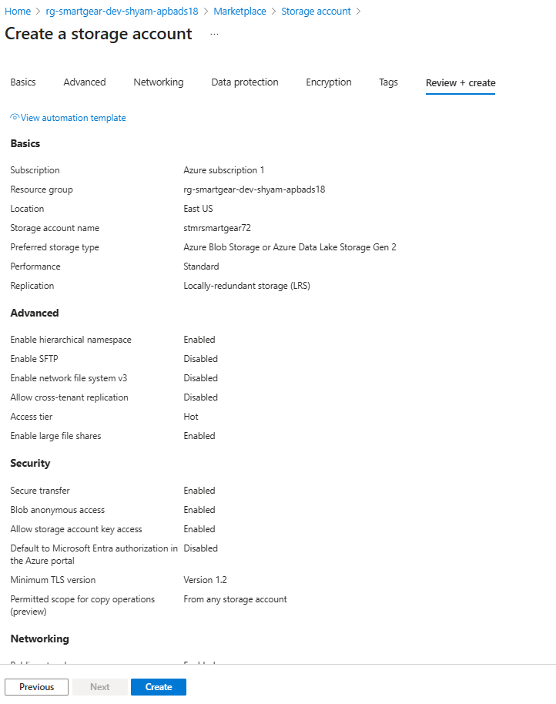

{

"id": "/subscriptions/8e8d725d-f149-4946-a78e-9907fa242122/resourceGroups/rg-smartgear-dev-shyam-apbads18",

"name": "rg-smartgear-dev-shyam-apbads18",

"type": "Microsoft.Resources/resourceGroups",

"location": "eastus",

"tags": {},

"properties": {

"provisioningState": "Succeeded"

},

"apiVersion": "2020-06-01"

}

